**Unimodal Image**

T-SNE Results for Image training Data -

All 8500 data, 5.0 perplexity

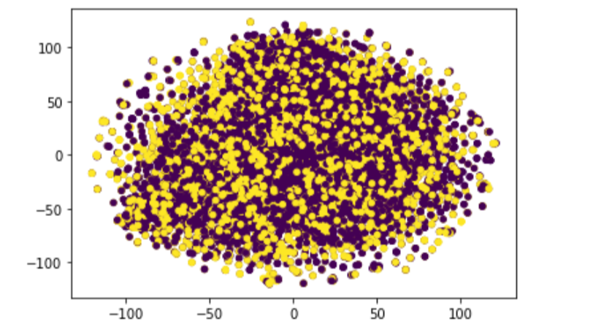

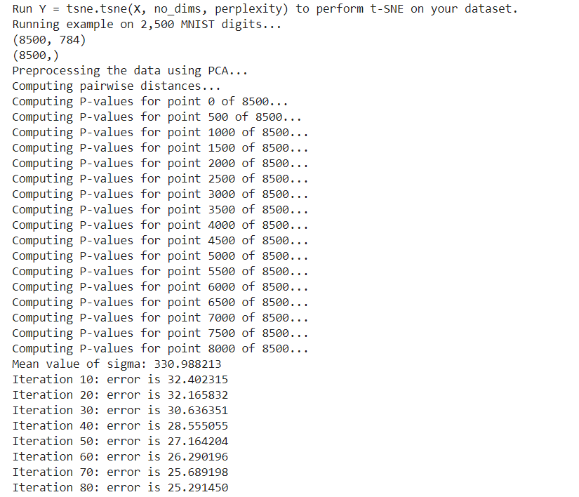

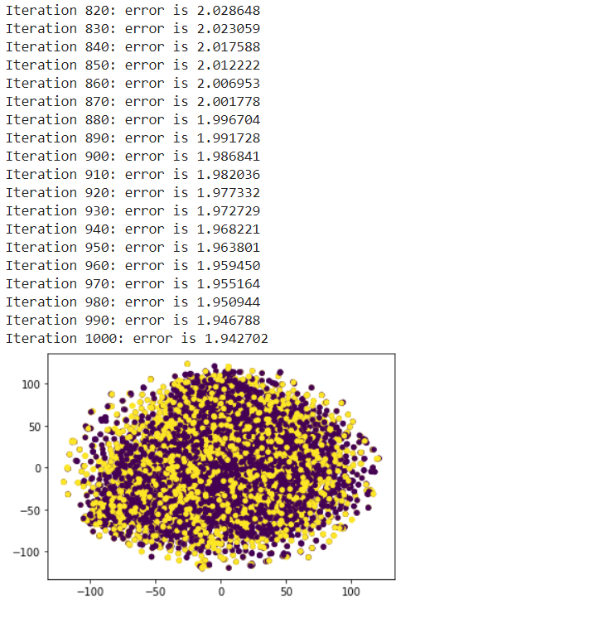

With Perplexity = 5.0, Size = 8500 images, Size of each image = (28*28) after resizing.

Shows that the training images are well balanced.

Also added the error values and the p_values for this run.

T-SNE Results for dev set-

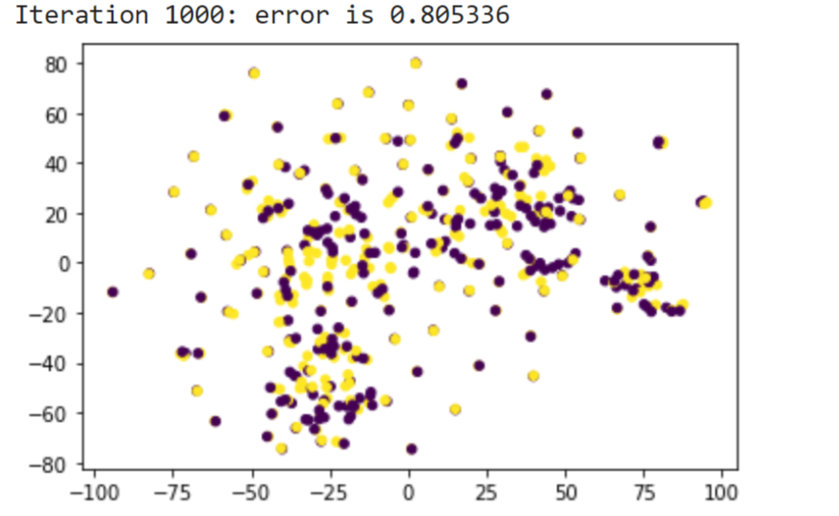

With Perplexity = 5.0, Size = 500 images, Size of each image = (28*28) after resizing.

Shows that the dev images are well balanced.

**A lot of overlapping hateful and non-hateful images on top of each other. This shows that the images have high similarity but with different text (which makes the labels different). The same case should be there with the Training set as well, but due to the large amount of data, less visible.**